Mini Exercise 1 – XOR (Regression)

- Using PyTorch, train a neural network to predict the XOR truth table using the Regression technique.

- The inputs and outputs of the XOR table are shown below.(regression problems) -> like 3 num sum problem.
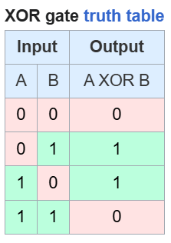
- Your network should accept two inputs (e.g. 0 and 1) and produce a single output value (e.g. 1). (for nural net need to do soft max 90%1 and 10%0 for diff input)

- Use the Mean Square Error loss function for your network.

- You are free to choose the number of layers, no. of neurons in each layer, and activation functions to use for your network.

- Train your network such that it consistently predicts a (correct) value that is very close to 0.0 or a (correct) value that is very close to 1.0, depending on the inputs.

All the weights are same for all inputs batch

